FRIENDS AND FAMILY TEST
Results for December 2023

Thank you to all the patients who completed a friends and family test survey in December 2023.

- How likely are you to recommend our practice to family and friends if they needed similar care or treatment?
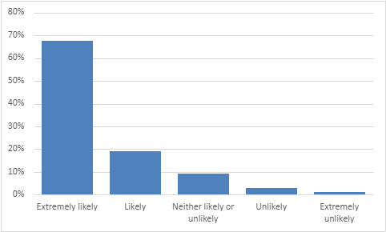
67% are extremely likely to recommend the practice.
19% are likely to recommend the practice.
9% are neither likely nor unlikely to recommend the practice.
3% are unlikely to recommend the practice.
1% are extremely unlikely to recommend the practice.

- If we could change one thing about your care or treatment, what would it be?
- Everything brilliant. Just like to say thank you, fantastic surgery and staff.
- Wonderful Acreswood. All staff are friendly and efficient. You are awesome.
- Excellent service. Great staff. Helpful admin staff. Treated with respect and professionalism.
- Hats off to some of the doctors especially Dr Hart. Dr Hart is a lovely lady, very professional.
- Justine is amazing, very friendly, compassionate and caring. She has a wonderful manner.
- Ms Mehrun and Dr Craghill are extremely good and thorough.
- Dr Harris was amazing. Tracey was very lovely and gives you time to talk.
- Dr Brown (especially) and physio fantastic. Dr Rawson helpful and understanding.
- Saw Dr Challa yesterday, excellent. Sue on reception is brilliant, very caring.
- Wonderful to be able to phone in the morning and have an appointment the same day.
- More face-to-face appointments and shorter waiting times. More available appointments.
- Better lit carpark. More disabled parking.
- Better access to appointments. Allow online booking for doctors and ANP.
- As an older person, I have found the changes since Covid difficult to get used to.
- Have less posters in the surgery, it’s overwhelming.
- More regular steroid injection clinics. Have well women clinics again.
- More staff on reception during busy periods.
- The location of the touch screen patient sign-in monitor.
- Less queuing on the phone.
- To be able to see the same doctor every time.

